Lindenwold Middle School
Summer Reading Assignments
For Students Going Into Grades 5, 6, 7, & 8
Chance to win one of four
Clementon Park Season Passes
A $55 value!

Summer Reading “What Ifs”

What If… | Then…
What if I am absent and the teacher does not give me the summer reading book at the end of the school year? | It is your responsibility to obtain the summer reading book when you return. In the main office, beginning June 22nd to September 1st, you will find extra copies of all the books and the directions for the projects that are due
What if I know I am moving to a different school over the summer? | Do not take a book. Find out about the summer reading assignment at your new school. Almost every school has a summer reading requirement.
What if I decide I don’t like my book? | Come to the office and switch your book, or download/buy/borrow your own copy of the new book. You are still responsible to return the original book.
What if I lose my book? | Come to office and report the book lost. You will receive a fine card for the book, but you can then check out a new one.
What if I lose my packet? | Download a new one from the middle school website. You do not need to print it all (the packet is not due; just the assignment mentioned within the packet).
What will happen if I don’t do my summer reading? | You will miss out on a great opportunity to increase your reading ability. You will also receive a 0 for your first language arts grade, which will negatively affect your grade for the first marking period
What if I don’t have the materials at home to do my summer reading? (Computer, paper, markers, etc). | If you have read the book but would like some help starting the project, you should come to Lindenwold Middle School library on Thursday, August 24th from 9-12 for a Summer Reading Project Day. Check out the LMS Summer Reading Blog below for more information.
What if I read more than one book? | Great! Record all additional books on your reading log. You will get a ticket to win a Clementon Park Season Pass for every book you read.
ATTENTION: Your summer reading project will be counted as a grade for the first marking!
Lindenwold Middle School Summer Reading List
Choose one book from your grade level list and complete one project

Entering Grade 5:

Provided Titles | Lexile | F&P Level
Geronimo Stilton: The Discovery of America | N/A | Q
Big Nate: In a Class By Himself | 500L | S
Werewolves Don’t go to Summer Camp | 590L | M
The Jacket | 640L | Q
School Story | 760L | R
Janitor’s Boy | 770L | S
Star Wars: The Force Awakens (A Junior Novel) | 700L | S
Frindle | 830L | R
The Good, The Bad, and The Goofy | 620L | P

Entering Grade 6: * Any book from the “Going Into 5th Grade List” with teacher permission

Provided Titles | Lexile | F&P Level
Odd Squad: Zero Tolerance | 490L | S
Crash | 560L | V
Loser | 650L | U
Stargirl | 590L | V
The Fire Within | 630L | T
The Kane Chronicles: The Red Pyramid: The Graphic Novel | 650L | Y
Maniac Magee | 820L | W
The Blood of Olympus | 690L | W
Magnus Chase and the Gods of Asgard #1: The Sword of Summer | 630L | Y

Entering Grades 7 or 8: * Any book from the “Going Into 6th Grade List” with teacher permission

Provided Titles | Lexile | F&P Level
Beastly | 580L | Z
Almost Home | 590L | Z
Romiette and Julio | 640L | Z
Last Book in the Universe | 740L | W
Matter of Trust | 740L | Z
Taking Sides | 750L | S
Dangerous Waters: An Adventure on the Titanic | 770L | V
The Maze Runner | 770L | X
We Beat the Street | 860L | W

Your task is to construct a six-panel brochure OR a 8 page digital presentation (PowerPoint) that breaks down the major ideas and elements of the book you read.
Project Choice #1:
Break It Down

1. Fold a piece of 8 1/2 " x 11" (or larger) paper into three equal sections.

2. Create specific sections of the brochure to DESCRIBING the following book elements. You may split them up as you wish, but make sure you have included the following:

- Main Character (Who is he/she? What is he/she like?) (use text to support your answer)
- 2 Secondary Characters (Who are they? What are they like? What do they want?)
  - Include a drawing/illustration/picture of the characters
- Setting (Where and when does the story take place and what how do these two elements affect the character, their problems, or their decisions?) (use text to support your answer)
  - Include a drawing/illustration/picture
- Conflict (What is the main character’s problem(s)?
  - Include a drawing/illustration/picture
- Climax (What was the most exciting moment or turning point in the story?)
  - Include a drawing/illustration/picture
- Resolution (How did the main character solve his/her problem?)
  - Include a drawing/illustration/picture.
- Theme (What did the author want to teach you about life through the struggles of the main character? Which 2 events most led you to learn this lesson?)
  - Include a drawing/illustration/picture
- Review (Did you like the book? What was your favorite part?)

3. If you choose to display your knowledge using PowerPoint (or another presentation tool such as Animoto, Prezi, etc), include a title slide (the book title and your name) and the six bullets above on individual slides.

Save and print a copy of your presentation/chart. You can also email it to your teacher on the first day of school.

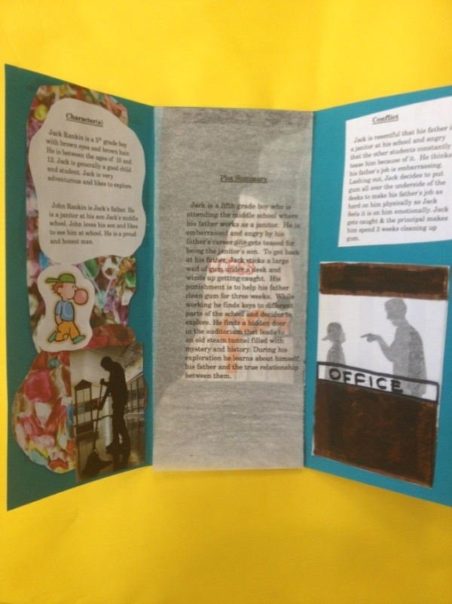
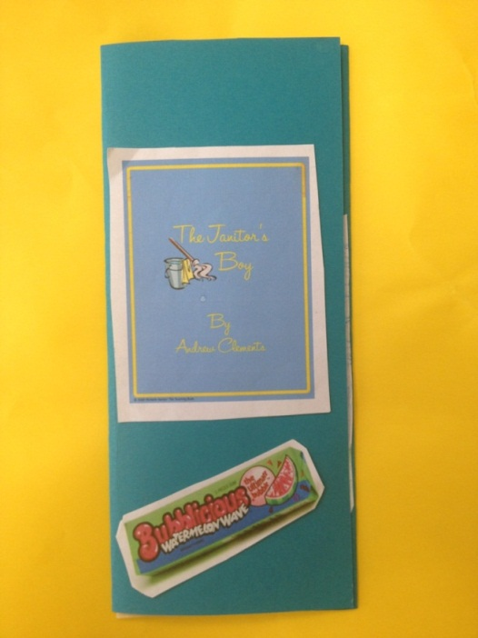
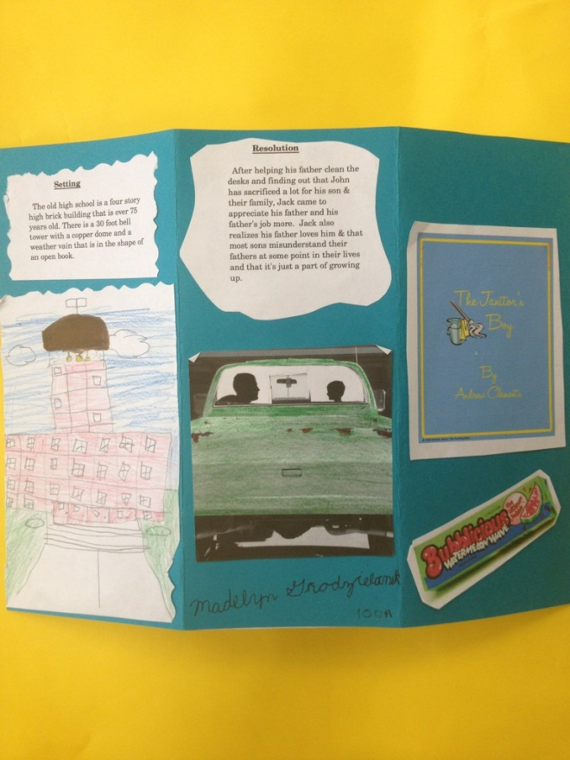
Break It Down” Example
Inside of Brochure
Cover of Brochure
Note: If using PowerPoint, turn each section of the brochure into a different slide.

Outside of Brochure

Project # 2:
Literary Analysis Chart

Your task is to complete the Literary Analysis Chart in this packet. You will answer questions about the major ideas and elements of the book you read. You will also create an illustration that demonstrates your understanding of the book.

1. Utilize the Literary Analysis Chart in this packet. Answer each question by writing or typing directly into the chart. If you need more space, use the back of the chart to complete your answer.

2. Please answer all questions in complete sentences and be sure to include specific text evidence or quotes from the text to support your answers.

3. Create an illustration that best summarizes your book and attach it to your chart.

Your project will be evaluated using the Summer Reading Rubric contained in this packet.

NAME:_______________________________ LITERARY ANALYSIS CHART Book Title:________________________________
Conflict/  Resolution | Describe the major conflict or problem the main character faces? How is the conflict resolved? | Cite one specific quote from the story to support your answer.
 |  | Quote: Page ___________
Character Description and Growth | Describe the main character. How does he/she change or develop through the story? Explain what they were like at the beginning of the novel and how they changed by the end. | Cite specific text evidence from the story to support how the character grew from the beginning to the end of the book. Give examples of what the character says or does to show their growth.
 |  | What the character says or does: Page ___________
 |  | What the character says or does: Page ___________
Theme | What was the main message or lesson about life the author chose to convey? | Which two events best support your ideas?
 |  | Event #1: Pg __________
 |  | Event #1: Pg __________
Figurative Language | Give an example of figurative language used in the novel (simile, metaphor, hyperbole, personification, alliteration, onomatopoeia). | Explain why the author uses this figurative language and explain what it means.
 | Type of Figurative Language: __________________  Example: Pg_________ | The author uses figurative language because….  The example shown means…
Illustration | Create an illustration that captures an important scene from the book. Write a short caption that describes the event.
Caption:

Project #3: Book Talk
Your task is to share ideas and your opinion of the book with your classmates during the first week of school, either in person or through a video.

1. To prepare for your book talk, be ready to answer or do the following:

- Give the title and author.
- Mention another book the author has written.
- Describe who the main characters are and what makes them different from each other. Choose at least one example from the text to support your explanations and provide evidence.
- Talk about the character’s conflict and what created it.
Consider choosing at least one example from the text to support your explanations and provide evidence.
- Discuss a climactic or exciting moment in the book.
Consider choosing at least one example from the text to support your explanations and provide evidence.
- Choose a page or two from the book to read aloud.
- Give two reasons why you give the book a “thumbs up” or a “thumbs down.”

2. If you are going to do the Book Talk in class, have your answers to the above questions written out so that you can do your best talking in front of the class.

3. If you are going to use your cell phone or video camera to film your book talk after you finish the book, email your language arts teacher your video on or before the second day of school. She will not show the class your book talk if you don’t want to share it.

NAME: ____________________________________ Student Score Total: ______ / 20 pts.
Summer Reading Project Rubric
 | 4 | 3 | 2 | 1
Content Knowledge | Knowledge of plot elements, theme, and details is excellent and evidenced in the project. | Includes essential knowledge of plot but lacks main idea or supporting details. | Broad knowledge of plot is demonstrated but project is missing critical details; only a portion of the book was read. | Content is weak or there are several factual errors about the text.
Textual Evidence and Support | Project incorporates textual evidence that is specific and convincing which successfully support claims in the writing. | Project attempts to incorporate textual evidence to support claims in the writing with some success. | Project attempts to incorporate textual evidence to support claims in the writing, but does so unsuccessfully. | Project uses information pulled directly from the internet (copy and pasted). Project details are plagiarized.
Neatness / Creativity | Project shows considerable originality and inventiveness. Creative graphics are used to support text. | Project was creative at times; thoughtfully presented with good effort. | Project had a few original touches with moderate effort regarding neatness and presentation. | Project shows little or no effort regarding neatness and presentation
Grammar / Mechanics  OR  Oral Presentation | The author makes no errors in grammar, mechanics, and/or spelling.  OR  Speaks about book with confidence using direct eye contact, seldom looking at notes holding the attention of the entire audience | The author makes a few errors in grammar, mechanics, and/or spelling, that does not interfere with the meaning of the text.  OR  Speaks about book with some confidence using consistent eye contact, but returning to notes | The author makes some errors in grammar, mechanics, and/or spelling, that sometimes interferes with text meaning  OR  Speaks about book with minimal confidence making little eye contact while reading mostly from notes | The author makes numerous errors in grammar, mechanics, and/or spelling that interferes with text meaning  OR  Speaks about book making no eye contact; entire report is read from notes
Timeliness | Project is submitted by the September 13, 2107 due date. | Project is submitted within a few days of due date. | Project is submitted within one week of due date. | Project is submitted by Friday, September 22, 2017.

Lindenwold Middle School
Summer Reading Project Day

You’ve been given a summer reading book. You’ve finished reading it. You are ready to complete your project when you ask yourself…
HOW DO I DO IT?

Come to Summer Reading Project Day

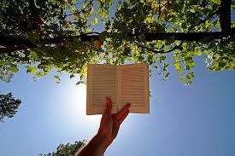
It is important for students to start the school year off on a positive note. The summer reading project counts as a language arts classwork grade and it is due on September 13, 2107! Therefore, we ask that parents work with their children to complete the reading and then the assignment. Each student was given a copy of the book to sign out, or you can borrow one from the Lindenwold or Camden County Libraries or buy your own.

We are offering our students an opportunity to come in and discuss their summer reading project with our Language Arts staff to answer questions and help guide them in completing the projects. Students that are interested should read the book by the date and report to the Lindenwold Middle School library on Thursday, August 24th from 9:00 – 12:00. You can come at any time between those hours. Students can come by with completed projects to get advice or can work with our teachers to start the projects. It is a great opportunity to ensure success on your first project for the 2015-2016 school year.

